|  | **Library Management System Using Python**  **Analysing Report** |
| --- | --- |

**Team P2-1166A Members:**

| **Employee Name** | **Employee ID** | **Employee Role** |
| --- | --- | --- |
| **Yeo You Ming** | **2401166** | **Lead Business Analyst** |
| **Gabriel Khoo** | **2401600** | **Business Analyst** |
| **Nathan Chua Ze En** | **2402825** | **Technical Analyst** |
| **Nathaniel Liong** | **2400530** | **Technical Analyst** |
| **Koh Li Sheng** | **2401715** | **Business Analyst** |

**\*Refer to Appendix C for organizational chart**

**Date: 13 February 2026**

**Document Version: 1.0**

**Document ID: AR-2026-0001**

**1. Executive Summary 4**

1.1 Purpose of Analysis 4

1.2 Business Context and Problem Overview 4

1.3 Proposed Solution and Intended Benefits 4

1.4 Analysis Scope and Approach 4

1.5 Overall Assessment and Conclusion 5

**2. IRC – Incongruous Requirements Checklist 5**

**3. BCIC – Analysing Method Application 5**

3.1 Breakdown 5

3.1.1 Fine Enforcement and Blocking Logic 5

3.1.2 Catalogue Display Consistency 6

3.1.3 User Profile Scope and Data Exposure 6

3.1.4 “Fast Report” Requirement 6

3.1.5 Cogent Requirements 6

3.2 Clarify 6

3.2.1 Clarification of Fine Enforcement and Blocking Behaviour 7

3.2.2 Clarification of Catalogue Display Behaviour 7

3.2.3 Clarification of User Profile Scope and Data Exposure 7

3.2.4 Clarification of System Capacity Expectations 7

3.3 Interpret 8

3.3.1 Fine Enforcement and Blocking Logic - Corrected Requirements 8

3.3.2 Catalogue Display Behaviour - Corrected Requirements 8

3.3.3 User Profile Scope and Data Exposure - Corrected Requirements 8

3.3.4 Reporting and Performance Expectations - Corrected Requirements 9

3.4 Requirements Modelling 9

**4. Repository 9**

4.1 Purpose of the Repository 9

4.2 Repository Access 9

4.3 Site Organisation (Repository Structure) 10

**5. Account Manager Profile 10**

**6. Risks Analysis 11**

**7. Sign-off 11**

## 

**AI Usage Declaration**

SoftwareSolutions declares that AI-assisted tools were used in a **supportive, non-substitutive capacity** during the preparation of this Analysis Report. AI tools assisted with structuring content, improving grammar and academic tone, and organizing analytical sections in alignment with BCIC and IRC methodologies.

**All analytical reasoning, requirement interpretation, clarification outcomes, corrected requirements, diagrams, and conclusions are original work** of the SoftwareSolutions analysis team. AI tools did not generate project-specific requirements, perform independent analysis, or replace human judgment.

The team takes full responsibility for the accuracy, originality, and integrity of all submitted content. AI assistance was used in accordance with academic integrity principles to enhance communication quality, not to circumvent learning objectives.**Plagiarism Declaration**

SoftwareSolutions declares that this Analysis Report and all associated artefacts represent **original work** carried out by the SoftwareSolutions analysis team for academic purposes under ICT2113: Software Modelling and Analysis.

All content has been produced through the application of recognized requirements analysis methodologies (BCIC and IRC) based on the officially provided Project Specification. Referenced concepts, frameworks, or standards are used appropriately for academic purposes and have not been reproduced verbatim without acknowledgement.

This submission contains no plagiarised material and does not replicate work submitted for other modules or assessments. Industry practices are applied through original interpretation contextualised to this project scope.**Declared by:  
SoftwareSolutions**Vendor for LittleLibrary Library Management System Project

**Date:** 13 February 2026

**Signed By:** *Yeo You Ming, Gabriel Khoo, Nathan Chua Ze En, Koh Li Sheng, Nathaniel Liong*

# **1. Executive Summary**

## **1.1 Purpose of Analysis**

This Analysis Report presents the vendor’s evaluation of the proposed **web-based Library Management System (LMS)** for **LittleLibrary**, a public-sector organisation operating under the Singapore Library Board (SLB). The purpose of this analysis is to assess the **feasibility, clarity, associated risks, and delivery readiness** of the system requirements outlined in the Project Specification, prior to proceeding with detailed design and implementation.

## **1.2 Business Context and Problem Overview**

LittleLibrary is currently experiencing operational inefficiencies arising from **manual and fragmented record-keeping processes**, particularly in areas such as book inventory tracking, loan management, fine calculation, and report generation. These challenges are expected to intensify with increasing visitor volumes and the organisation’s obligation to comply with government regulations, including the **National Record-Keeping of Singapore (NRKS)** and prevailing data privacy requirements.

## **1.3 Proposed Solution and Intended Benefits**

The proposed LMS is designed to **centralise library operations**, automate critical workflows, and substantially reduce administrative workload. By introducing consistent rule enforcement, real-time data access, and improved reporting capabilities, the system supports operational scalability while aligning with Singapore’s **Smart Nation initiative**.

## **1.4 Analysis Scope and Approach**

This report reviews the vendor's internal requirements analysis and validation approach, including the application of BCIC and IRC methods. The analysis examined **31** requirements from the Project Specification, of which **27 (87%)** were identified as cogent and implementation-ready, covering functional areas including record-keeping compliance, data privacy, user registration, inventory management, fine calculation, and comprehensive technical specifications for deployment, security, and operational maintenance.

The Breakdown phase identified **4 critical requirement areas (13%)** requiring clarification: fine enforcement and blocking logic, catalogue display consistency, user profile scope and data exposure, and performance thresholds. Through systematic application of the IRC screening tool, **4 major incongruities were identified and resolved**, resulting in **9 newly corrected or refined functional requirements** (FR-FIN-03 through FR-FIN-05, FR-CAT-01 through FR-CAT-03, FR-USR-01 through FR-USR-04, and NFR-PERF-01).

The analysis further identified and assessed **10 project risks** across technical, operational, and stakeholder management domains, and produced updated requirements models, including a revised use case diagram and a comprehensive data dictionary with 7 table schemas.

## **1.5 Overall Assessment and Conclusion**

Based on the analysis conducted, the project is assessed to be **viable for execution**, provided that identified risks are proactively managed throughout the development lifecycle. Of the **10** risks identified**, 3 (30%)** are classified as extreme-priority (R-01 through R-03)**, 2 (20%)** as high-priority (R-04 and R-05)**, 3 (30%**) as moderate-priority (R-06 through R-08)**,** and **2 (20%)** as low-priority (R-09 and R-10). Critical success factors include proactive management of system security, operational handover, and change management, particularly given the customer's risk-averse posture on data privacy and the competitive tender environment. All ambiguous requirements identified during Breakdown have been successfully clarified and interpreted into cogent, implementation-ready specifications, with **100% traceability** maintained through updated use case models and data dictionary artefacts.

# **2. IRC – Incongruous Requirements Checklist**

This Incongruous Requirements Checklist (IRC) represents SoftwareSolutions’ internal checklist used to examine the client’s Project Specification (PS) for potential incongruities before the formal application of the BCIC analysing method. The IRC functions as a systematic screening tool to identify ambiguous, incomplete, inconsistent, or unrealistic requirements before they are analysed through Breakdown, Clarify, Interpret, and Categorize activities.

The full checklist is provided in **Appendix A** for reference.

# **3. BCIC – Analysing Method Application**

This section documents the vendor’s application of the **BCIC analysing method** to the **Project Specification (PS)** for the Library Management System. As the PS represents the authoritative customer document at this stage of the project, the analysis focuses exclusively on identifying incongruities, resolving ambiguities, and transforming clarified intent into cogent, implementation-ready requirements before formal specification.

## 

## **3.1 Breakdown**

The Breakdown activity examines the PS to separate **cogent requirements** from those that are **ambiguous, incomplete, or potentially incongruent**. Using SoftwareSolutions’ Internal Incongruous Requirements Checklist (IRC), the following issues were identified.

## **3.1.1 Fine Enforcement and Blocking Logic**

The PS clearly defines fine calculation rules (REQ-L1-007.1, REQ-L1-007.2) and includes a blocking rule preventing users from borrowing books when fines are unpaid (REQ-L1-005.3). However, the enforcement mechanism for lifting this block is not fully specified. In particular:

* The exact system behaviour following partial or failed payment is not explicitly stated.
* The point at which the blocking rule is lifted is not explicitly defined.
* The linkage between fine payment confirmation and account status update is implicit rather than explicitly defined.
* The Project Specification specifies the blocking condition and payment confirmation requirement, but does not explicitly describe the system process or component responsible for lifting the block upon successful payment.

This introduces a potential risk to system correctness and user experience during fine settlement.

## **3.1.2 Catalogue Display Consistency**

The PS addresses catalogue display behaviour by specifying a standard vertical scrolling mechanism for mobile devices (REQ-L1-001.2) and a grid-based layout for desktop contexts. However, the PS does not explicitly define the boundary conditions under which these display modes apply. In particular, it remains unclear whether mobile devices are strictly constrained to vertical scrolling only, or whether alternative layouts (e.g. grid or column-based catalogue views) may be adopted under certain conditions, such as phone sizes. While the overall intent of the responsive catalogue presentation is clear, the operational limits of the display constraint remain implicit.

## **3.1.3 User Profile Scope and Data Exposure**

The PS explicitly lists profile attributes such as user name, account age, and genre preferences (REQ-L1-002.2), and also mandates data privacy controls (REQ-L0-003.2). However, the PS does not clearly specify:

* Whether loan history and outstanding fines are displayed by default on the profile page.
* The level of detail visible to the user versus other users.

This creates ambiguity in balancing transparency with privacy obligations.

## **3.1.4 “Fast Report” Requirement**

The PS repeatedly references the need for “fast report” generation (REQ-L1-003.1, REQ-TECH-003.3) and defines concurrency targets (REQ-TECH-003.1). However:

* No quantitative response-time thresholds are stated.
* The definition of “real-time” reporting is qualitative rather than measurable.
* Performance expectations for peak versus normal loads are not distinguished.

This presents a feasibility risk if expectations are misaligned between the customer and the vendor.

## **3.1.5 Cogent Requirements**

A list of all cogent requirements from the Project Specifications are listed in **Appendix A.**

## **3.2 Clarify**

The Clarify activity determines the **authentic purpose and substance** of the incongruent requirements identified during Breakdown. The SoftwareSolutions team (Org Chart is provided in **Appendix C** for reference) went down to physically meet up with the customer. Clarification was conducted through structured stakeholder engagement, supported by explanatory representations to surface and resolve difficulties associated with priority requirements. Where direct stakeholder confirmation was not feasible at this stage, intent was clarified through reasoned interpretation of the Project Specification, supported by domain knowledge and industry practice.

To facilitate clarification, SoftwareSolutions employed **informal explanatory artefacts** (Paper Napkin Prototypes) to reason about ambiguous requirement behaviour and to validate interpretations internally. Where clarification could not be fully resolved, assumptions were explicitly recorded for confirmation during subsequent specification and stakeholder review.

## **3.2.1 Clarification of Fine Enforcement and Blocking Behaviour**

Clarification confirmed that borrowing restrictions are designed to remain in effect until outstanding fines are fully settled, and that account status updates occur only after successful payment confirmation. Partial payments or failed payment attempts are not intended to lift borrowing restrictions. This clarification resolves the earlier ambiguity regarding the conditions under which borrowing privileges are restored and establishes a clear enforcement boundary for subsequent interpretation and categorisation activities.

An updated interpretation of these requirements can be found in **3.3.1**.

## **3.2.2 Clarification of Catalogue Display Behaviour**

Clarification confirmed that the intent of the catalogue display requirements is to provide a consistent and usable browsing experience across devices, while supporting responsive adaptation. Vertical scrolling represents the primary interaction pattern, with layout variations depending on available screen real estate. Informal paper napkin prototypes were used to reason about possible responsive behaviours and to validate internal understanding of the requirement intent.

The prototype is provided in **Appendix B** for reference.

An updated interpretation of these requirements can be found in **3.3.2**.

## **3.2.3 Clarification of User Profile Scope and Data Exposure**

Clarification confirmed that user profiles are intended to support self-management and transparency while enforcing strict role-based access control. Users may view and manage their own profile information, while administrative users have extended privileges to manage other users’ accounts. Informal paper napkin prototypes were used to reason about profile visibility differences between user and admin roles.

The prototype is provided in **Appendix B** for reference.

An updated interpretation of these requirements can be found in **3.3.3**.

## **3.2.4 Clarification of System Capacity Expectations**

Clarification resolved that references to “fast” or “real-time” by combining business operations constraints, such as number of reports and time intervals, and hardware constraints, such as RAM and processing power. A final conclusive number of 200ms was agreed upon, as it adheres to both constraints.

An updated interpretation of these requirements can be found in **3.3.4**.

## **3.3 Interpret**

The Interpret activity corrects and replaces all incongruent requirements identified during Breakdown into **cogent, unambiguous, and standards-aligned requirement statements**, presuming that clarification has reached agreement on intent. At this stage, SoftwareSolutions revises ambiguous and compound statements from the Project Specification into **atomic, testable requirements** suitable for inclusion in an IEEE-style Software Requirements Specification (SRS).

## **3.3.1 Fine Enforcement and Blocking Logic - Corrected Requirements**

**Original issue:**The PS defines fine calculation and blocking rules but leaves account unblocking behaviour implicit. The rules for fine enforcement and blocking are not in an independent section. Client has agreed to create a new requirement section for fine and enforcement logic.

**Corrected requirements (New section):**

* **FR-FIN-01 (From 5.2 Commercial Rules)**: The system **shall** automatically calculate an overdue fine of SGD 0.20 per day for each overdue book.
* **FR-FIN-02 (From 5.2 Commercial Rules)**: The system **shall** apply a one-time fee of SGD 10.00 for each book marked as damaged or lost.
* **FR-FIN-03 (From 5.2 Commercial Rules)**: The system **shall** prevent a user from borrowing new books while outstanding fines exist on the user’s account.  
  **FR-FIN-04 (NEW)**: The system **shall** lift borrowing restrictions **only after** successful payment confirmation is received from an external payment gateway.
* **FR-FIN-05 (NEW)**: Failed or incomplete payment transactions **shall not** change the borrowing status of the user.

## **3.3.2 Catalogue Display Behaviour - Corrected Requirements**

**Original issue:**The PS specifies vertical scrolling for mobile and grid view for desktop, but boundary conditions and fallback behaviour are implicit.

Using the paper napkin models, the previously incongruent requirements were corrected.

**Corrected requirements:**

* **REQ-L1-001.1 → FR-CAT-01**: The system **shall** present the book catalogue using a vertical scrolling layout on mobile devices.
* **REQ-L1-001.1 → FR-CAT-02**: The system **shall** present the book catalogue using a grid-based layout on desktop devices.
* **FR-CAT-03 (NEW)**: The system **shall** apply responsive layout adaptations based on client device characteristics without altering catalogue functionality.

## **3.3.3 User Profile Scope and Data Exposure - Corrected Requirements**

**Original issue:**Profile visibility, transparency, and privacy responsibilities were partially conflated.

Using the paper napkin models, the previously incongruent requirements were corrected.

**Corrected requirements:**

* **REQ-L1-002.2 → FR-USR-01**: The system **shall** allow users to view their own profile information, including user name, account age, active loans, and outstanding fines.
* **REQ-L1-002.3 → FR-USR-02**: The system **shall** allow users to manage their genre preference settings.
* **REQ-L1-005.2 → FR-USR-03**: The system **shall** restrict access to extended user information to authorised administrative roles only.
* **FR-USR-04 (NEW)**: The system **shall not** expose sensitive personal or financial data in user-visible interfaces.

## 

## **3.3.4 Reporting and Performance Expectations - Corrected Requirements**

**Original issue:** “Fast” and “real-time” reporting requirements were qualitative and ambiguous.

**Corrected and replaced requirements (SRS-ready):**

* **REQ-TECH-003.3 → NFR-PERF-01**: The system **shall** generate operational reports (issues and fines) within a response time (<200ms) that supports routine administrative use under normal system load (≤20,000 concurrent users).

## **3.4 Requirements Modelling**

Based on the outcomes of the BCIC analysis and the corrected requirements, SoftwareSolutions has updated the requirements models to ensure consistency and traceability. The revised **Use Case Diagram** **(Appendix D)** and **Data Dictionary** **(Appendix E)** reflect the clarified system behaviour and refined requirement set.

# 

# **4. Repository**

## **4.1 Purpose of the Repository**

Following the BCIC and IRC activities, the **Project Specification (PS)** has undergone regulated revision to produce requirements that are clear, consistent, and SRS-ready. The repository is established to preserve these refined artefacts in a structured and auditable manner.

Specifically, the repository supports:

* **Collaboration** among SoftwareSolutions’ analysis team during analysis and specification
* **Controlled handover** into subsequent specification, design, and implementation phases

## **4.2 Repository Access**

The repository is hosted on a **public Git-based platform** to allow transparent access for assessors and stakeholders.

**Repository link (public):** <https://github.com/Forfeit-15/pd112-library-lms-softwaresolutions>

All analysed artefacts and supporting models are maintained under version control to ensure integrity and accountability of changes.

## **4.3 Site Organisation (Repository Structure)**

The repository is organised to separate artefacts by purpose and lifecycle stage. This ensures clarity, maintainability, and prevents analysis outputs from being obscured by downstream implementation work.

**Logical Structure**

**Documentation Layer (/docs)**

* Analysis report artefacts (Executive Summary, BCIC Analysis, IRC outcomes)
* Project Specification (PS)

**Modelling Layer (/models)**

* Requirements models used for stakeholder communication and validation
* Use case diagram(s) and supporting model images
* Data dictionary artefacts aligned with requirements

**Implementation Layer (/src)**

* Python/Django source code for the Library Management System
* Configuration and deployment artefacts (e.g., Docker files where applicable)

**Repository Entry Point (README.md)**

* Repository navigation guide
* Artefact relationships
* Instructions to locate analysis vs models vs implementation

This organisation ensures that requirements analysis artefacts remain distinct from implementation assets, reducing the risk that analysis outputs are altered, diluted, or overlooked during development.

# **5. Account Manager Profile**

**Name:** Jane Tan

**Relationship with Little Library (customer):** 3 years, has worked on 1 project with Little Library previously.

**Experience:**

* Managed multiple mid-sized community service system implementations, including booking, inventory, and user-account platforms used by public-facing organisations.
* Worked closely with frontline staff to translate operational pain points (slow reporting, manual tracking, inconsistent enforcement of rules) into clearly scoped functional requirements.
* Coordinated system rollouts involving role-based access control, ensuring separation between administrative users and general users to prevent misuse.
* Led post-deployment support and training activities, focusing on ease of adoption, system usability, and minimising disruption to daily operations.
* Facilitated feedback loops during testing phases to ensure delivered features matched real-world workflows, reducing rework after deployment.

**This experience supports:**

* Operational efficiency goals.
* Clear admin vs user separation.
* Smooth transition from manual to digital workflows.

**Important Observations:**

* The customer is risk-averse on security and record-keeping, so they may not be willing to provide data that is sensitive but necessary for development.
* The customer is technically capable because there is an IT Manager and a Data Admin on their staff.

# **6. Risks Analysis**

*Potential pitfalls identified during analysis and their CRaM mitigation strategies.*

The project risks identified during the analysis phase are formally assessed using the Risk Matrix and summarised in the Risk Table, both of which are provided in **Appendix F**.

# **7. Sign-off**

*Validation of Analysis Phase.*

I, **Yeo You Ming, Lead Business Analyst**  , the undersigned, confirm that this Analysis Report accurately reflects the requirements derived from the LittleLibrary Project Specification. The project is approved for submission to the vendor and is ready to proceed to the Design Phase.

**1.0 (Document Version)**

______________________**(Signature)**

**13 / 02 / 2026 (Date)**

**APPENDIX A**

**Incongruous Requirements Checklist**

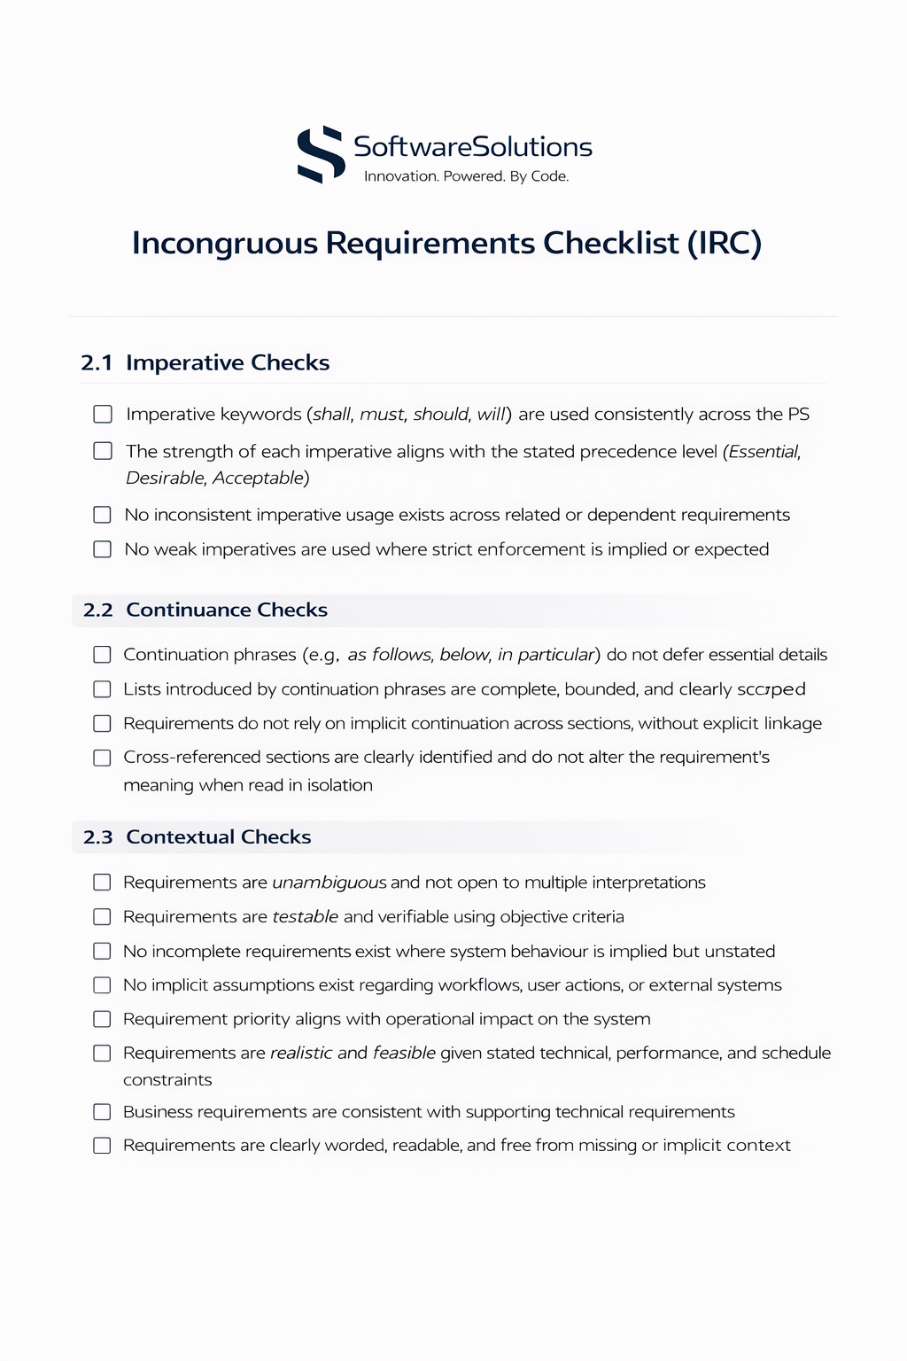

***Figure 1.1: Incongruous Requirements Checklist***

**Cogent Requirements**

**REQ-L0-003.1 (Record Keeping):** As a project under the Singapore Library Board (SLB), the system must maintain logs compliant with the National Record-keeping of Singapore (NRKS).

**REQ-L0-003.2 (Data Privacy):** While basic details are shown on profiles, the system must ensure no sensitive personal financial data is exposed publicly, mitigating the risk that "information stored can be susceptible to cyber hacks".

**REQ-L1-002.1 (Registration & ID Verification):** The system must enforce ID verification during the registration process.

**REQ-L1-002.3 (Recommendation Engine):** The system shall recommend books to the user based on the "preferences for genres" selected in their profile.

**REQ-L1-004.1 (Inventory Management):** Admins must be able to add, update, view, and delete books in the system to ensure real-time inventory accuracy.

**REQ-L1-006.1 (Order Filtering):** To generate "fast reports," the system must allow Admins to filter orders by date of transaction, return status (Returned vs. Not Returned), and expiration status (Overdue).

**REQ-L1-007.1 (Fine Calculation):** The system shall automatically calculate and apply a fine of $0.20 per day for EACH overdue book.

**REQ-L1-007.2 (Damage/Loss Fee):** The system shall support the application of a one-time fee of $10.00 for each book marked as damaged or lost.

**REQ-TECH-001.1 (Cloud Platform):** The system shall be deployed on Amazon Web Services (AWS) using either EC2 (t3.medium or higher) for application hosting, and Amazon RDS (MySQL 8.0) for managed database hosting.

**REQ-TECH-001.2 (Server OS & Runtime):** The application server shall run on Ubuntu Server 22.04 LTS, Python 3.11+, and Gunicorn as the WSGI server for Django.

**REQ-TECH-001.3 (Deployment Method):** The system shall support deployment via Docker using a Dockerfile for the Django application and a docker-compose.yml for multi-service orchestration.

**REQ-TECH-002.1 (Language & Framework):** The application shall be built using Python as the core programming language, utilising the Django web framework for robust backend logic.

**REQ-TECH-002.3 (Database Schema):** The system shall utilise a MySQL Database. The schema must be designed to support a UserAccount, Book, AdminAccount, Fine and Loan table.

**REQ-TECH-003.1 (Concurrency Load):** The hosted webpage must be capable of handling up to 20,000 concurrent users under maximum load conditions.

**REQ-TECH-003.2 (Surge Handling):** The server architecture must be provisioned to handle activity surges of 10% over the maximum estimation (approx. 22,000 users peak) without service degradation.

**REQ-TECH-004.1 (OS Compatibility):** The web application must be fully functional on client devices running Windows 7 or higher.

**REQ-TECH-004.2 (Hardware Specs):** The software must be optimised to run smoothly on machines with minimum specifications of Processor: i3 processor or higher, Memory: 4 GB RAM or higher, Storage: 100 GB ROM or higher.

**REQ-TECH-004.3 (Browser Versions):** The web application shall be fully functional on Chrome (latest 2 versions), Microsoft Edge (latest 2 versions), and Firefox (latest 2 versions).

**REQ-TECH-006.1 (Vulnerability Mitigation):** The IT implementation must include Django’s built-in CSRF protection and SQL Injection prevention via Django ORM.

**REQ-TECH-007.1:** Technical deliverables must include comprehensive documentation to ensure the system remains "easy to maintain" after the handover to SLB staff.

**REQ-TECH-008.1 (Admin Portal):** The system shall provide administrator functions using Django Admin Panel (/admin) as the primary administration interface.

**REQ-TECH-008.2 (Role Control):** Administrative access shall be restricted using Django is_staff and is_superuser, and role-based permissions using Django Groups & Permissions.

**REQ-TECH-008.3 (Operational Controls):** Administrators shall be able to perform Book CRUD management, User verification status updates, Fine adjustments (authorized staff only), and Audit viewing of payment transactions and fines history.

**REQ-TECH-009.1 (Backups):** The system shall support automated backups via Amazon RDS automated backups (daily, retain 7 days minimum) and application server snapshots (weekly).

**REQ-TECH-009.2 (Monitoring):** The hosted environment shall support monitoring using AWS CloudWatch for CPU, memory, disk, and network, with alerts via email when thresholds are exceeded.

**REQ-TECH-009.3 (Updates):** The system shall allow upgrades through a version-controlled deployment pipeline (Git repo) and a staging environment for testing before production deployment.

**APPENDIX B**

**Napkin Prototypes**

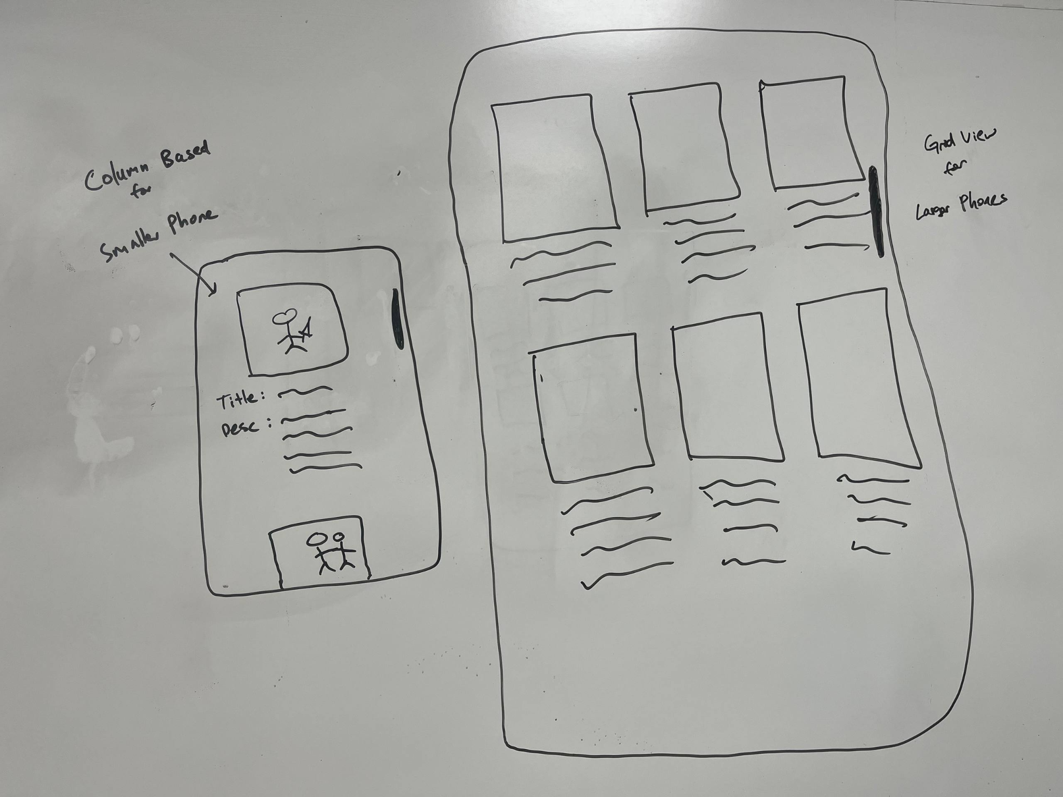

***Figure 2.1: Clarification of Catalogue Display Behaviour***

## 

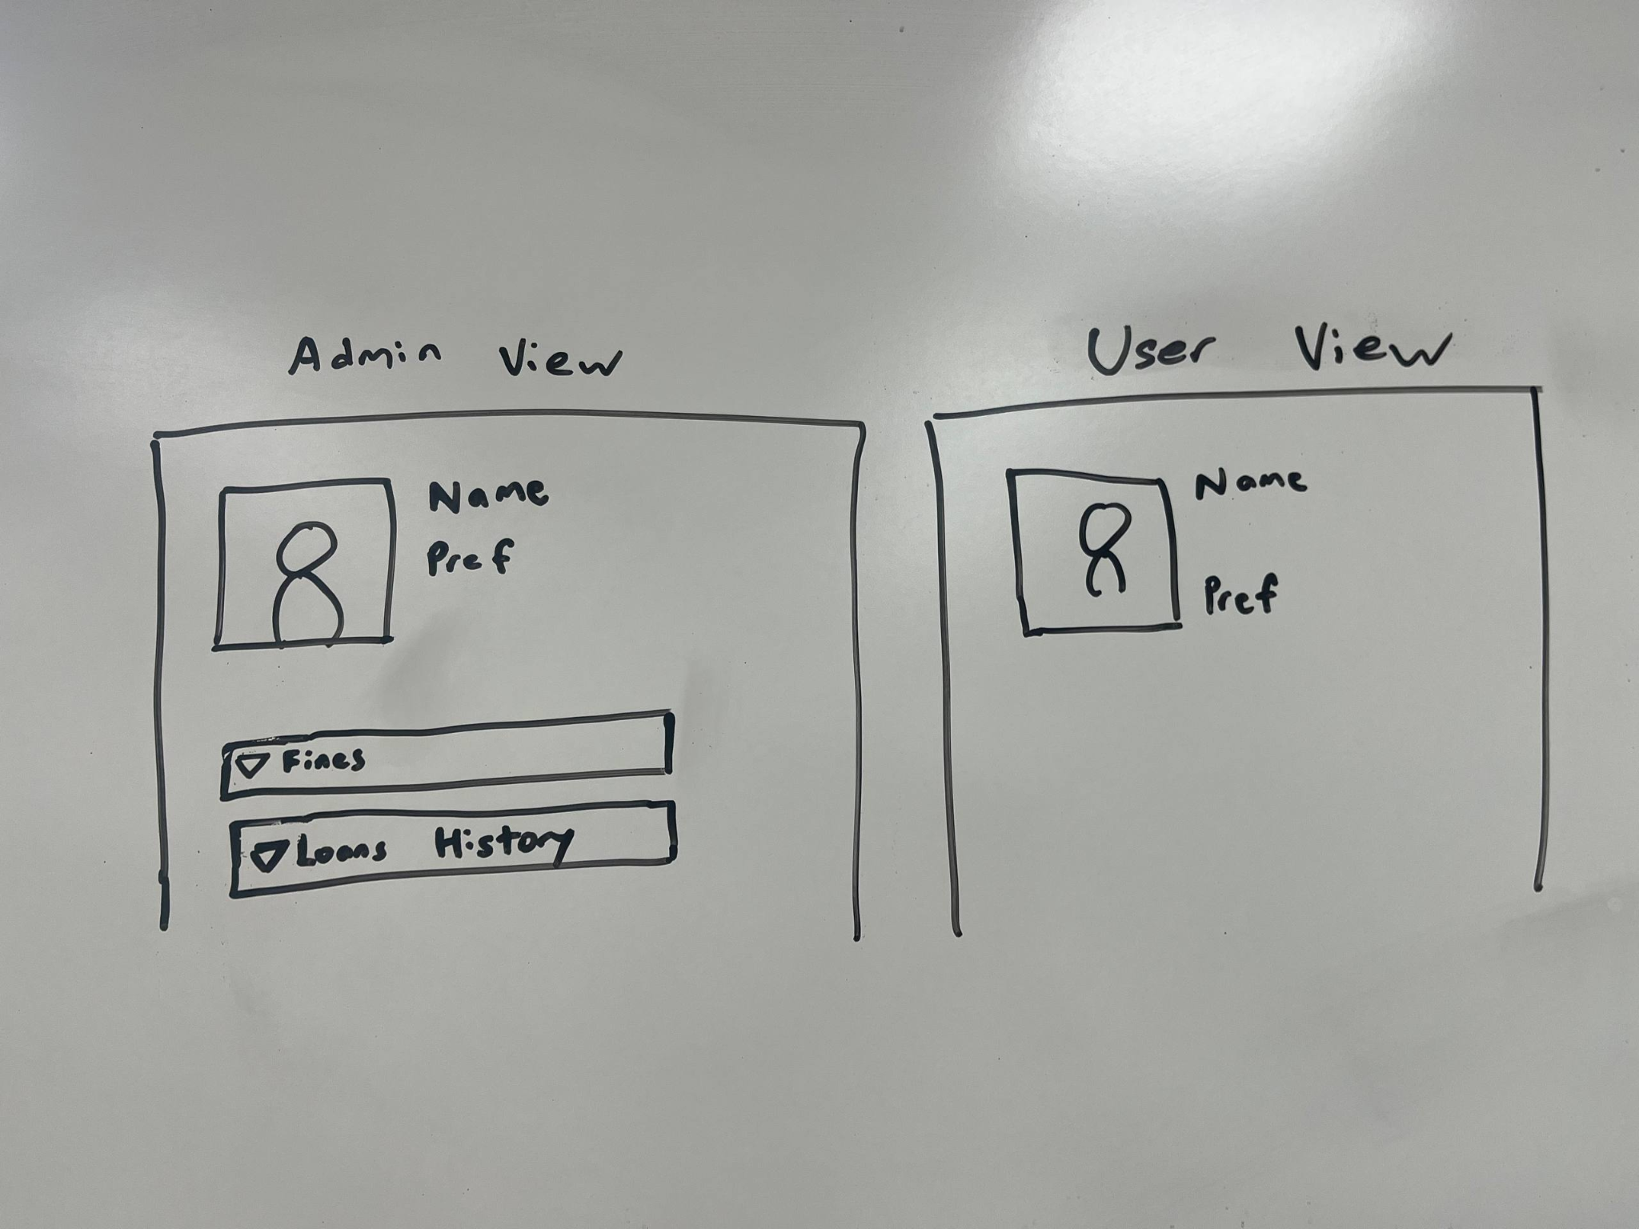

***Figure 2.2: Clarification of User Profile Scope and Data Exposure***

## 

## 

**APPENDIX C**

**Organization Chart**

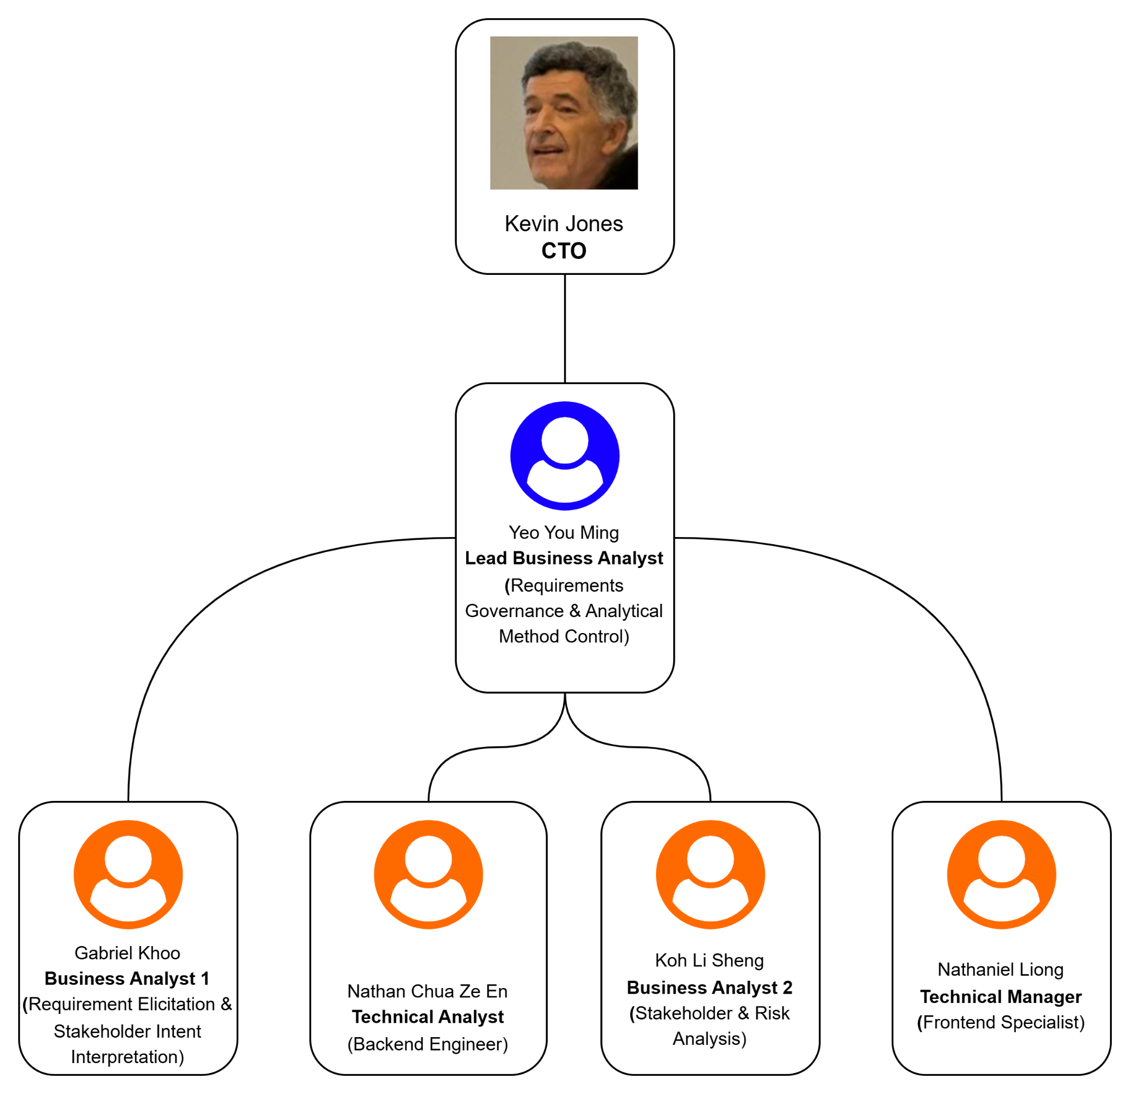

***Figure 3.1: Organization Chart***

**APPENDIX D**

**Use Case Diagram**

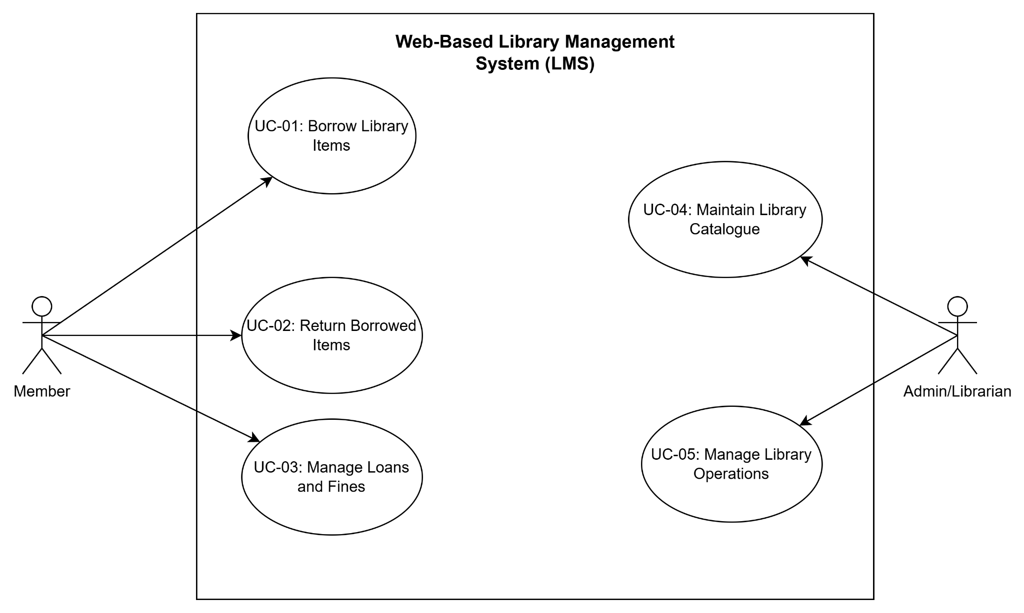

***Figure 4.1: Use Case Diagram***

**APPENDIX E**

**Data Dictionary**

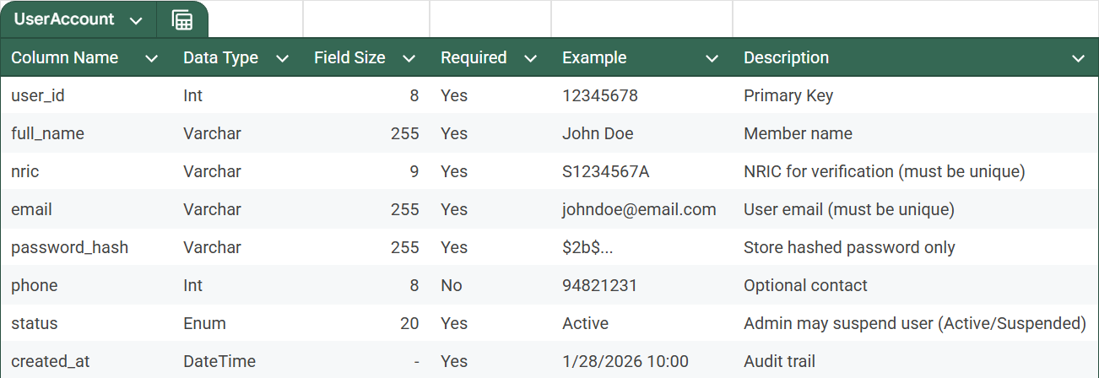

***Figure 5.1: UserAccount Table***

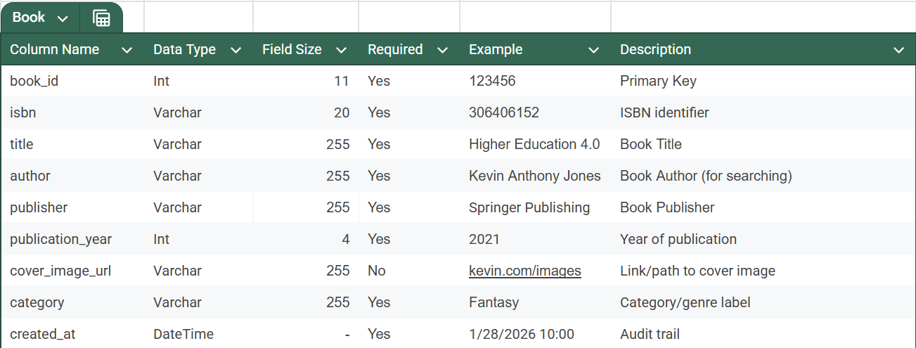

***Figure 5.2: BookTable***

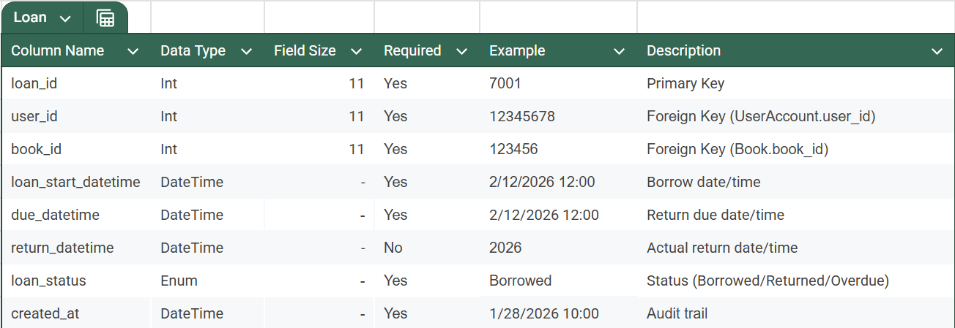

***Figure 5.3: Loan Table***

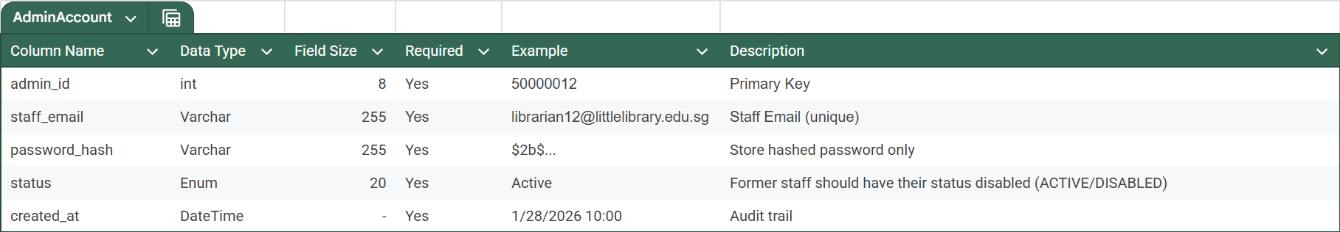

***Figure 5.4: AdminAccount Table***

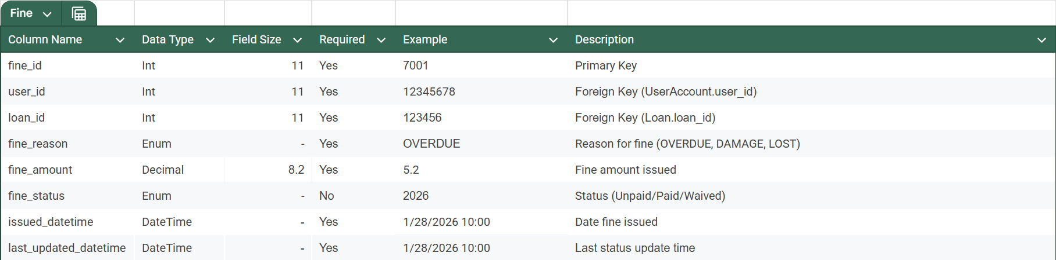

***Figure 5.5: Fine Table***

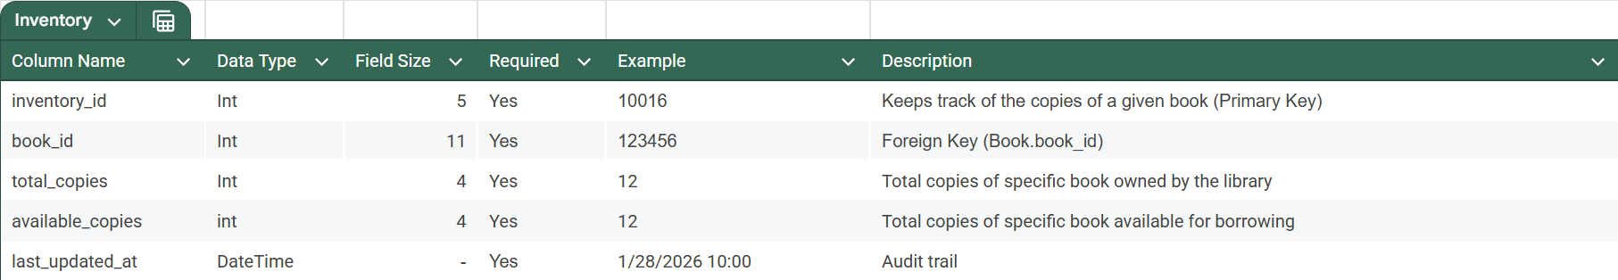

***Figure 5.6: Inventory Table***

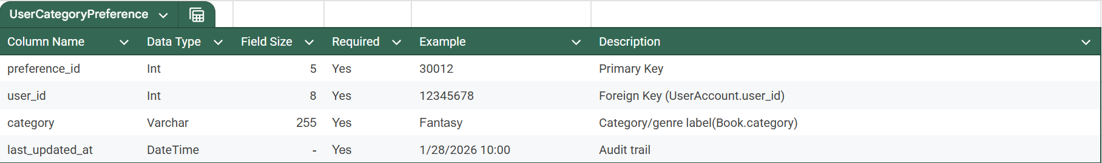

***Figure 5.7: UserCategory Table***

**APPENDIX F**

**Risk Analysis**

**Risk Value = Likelihood (L) × Severity (S), with severity levels categorised from Extreme (Red) to Low (Green). This structured scoring model ensures objective prioritisation of risks before proceeding to design.**

**Lower score = Higher Criticality**

**Risk Value = Likelihood (L) × Severity (S)**

**1–8 = Extreme (Red)**

**9–20 = High (Orange)**

**21–40 = Moderate (Yellow)**

**41–64 = Low (Green)**

| **L (down)/ S (right)** | **Catastrophic (1)** | **Critical (2)** | **Very Major (3)** | **Major**  **(4)** | **Moderate (5)** | **Minor (6)** | **Very Minor (7)** | **Negligible (8)** |
| --- | --- | --- | --- | --- | --- | --- | --- | --- |
| **Almost Certain (1)** | **1 x 1 = 1** | **2 x 1 = 2** | **3 x 1 = 3** | **4 x 1 = 4** | **5 x 1 = 5** | **6 x 1 = 6** | **7 x 1 = 7** | **8 x 1 = 8** |
| **Highly Probable (2)** | **1 x 2 = 2** | **2 x 2 = 4** | **3 x 2 = 6** | **4 x 2 = 8** | **5 x 2 = 10** | **6 x 2 = 12** | **7 x 2 = 14** | **8 x 2 = 16** |
| **Very Likely**  **(3)** | **1 x 3 = 3** | **2 x 3 = 6** | **3 x 3 = 9** | **4 x 3 = 12** | **5 x 3 = 15** | **6 x 3 = 18** | **7 x 3 = 21** | **8 x 3 = 24** |
| **Likely**  **(4)** | **1 x 4 = 4** | **2 x 4 = 8** | **3 x 4 = 12** | **4 x 4 = 16** | **5 x 4 = 20** | **6 x 4 = 24** | **7 x 4 = 28** | **8 x 4 = 32** |
| **Possible (5)** | **1 x 5 = 5** | **2 x 5 = 10** | **3 x 5 = 15** | **4 x 5 = 20** | **5 x 5 = 25** | **6 x 5 = 30** | **7 x 5 = 35** | **8 x 5 = 40** |
| **Unlikely (6)** | **1 x 6 = 6** | **2 x 6 = 12** | **3 x 6 = 18** | **4 x 6 = 24** | **5 x 6 = 30** | **6 x 6 = 36** | **7 x 6 = 42** | **8 x 6 = 48** |
| **Rare**  **(7)** | **1 x 7 = 7** | **2 x 7 = 14** | **3 x 7 = 21** | **4 x 7 = 28** | **5 x 7 = 35** | **6 x 7 = 42** | **7 x 7 = 49** | **8 x 7 = 56** |
| **Very Rare (8)** | **1 x 8 = 8** | **2 x 8 = 16** | **3 x 8 = 24** | **4 x 8 = 32** | **5 x 8 = 40** | **6 x 8 = 48** | **7 x 8 = 56** | **8 x 8 = 64** |

***Figure 6.1: Risk Matrix***

**RISK SEVERITY LEVELS (MOST TO LEAST): RED>ORANGE>YELLOW>GREEN**

| **Risk ID** | **Legacy Risk** | **L** | **Why?** | **S** | **Why?** | **Risk Value** |
| --- | --- | --- | --- | --- | --- | --- |
| **R-01** | Requirement changes by customer with Free-of-Charge expectation | **1** | Scope changes are extremely common once stakeholders see clarified requirements during BCIC. | **1** | Direct financial loss, scope creep, contractual conflict, schedule slippage. | **1** |
| **R-02** | Fine enforcement integration failure | **3** | External system integration introduces transaction and API synchronisation risks. | **1** | Incorrect borrowing permissions compromise system integrity and financial logic. | **3** |
| **R-03** | Data privacy / PDPA non-compliance | **4** | Role-based access misconfiguration is common in early development. | **1** | Legal liability, regulatory breach, reputational damage. | **4** |
| **R-04** | Performance expectation misalignment (“fast reports”) | **3** | Ambiguity identified during Breakdown; quantitative thresholds not defined in PS. | **3** | May cause UAT rejection and stakeholder dissatisfaction. | **9** |
| **R-05** | Tender timeline underestimation | **3** | Competitive bidding encourages optimistic schedule assumptions. | **4** | Compressed BCIC may cause incomplete clarification and downstream defects. | **12** |
| **R-06** | Customer not technologically versed | **2** | Domain staff may lack technical depth despite having IT support. | **6** | Slows decision cycles but manageable via models and prototypes. | **12** |
| **R-07** | No cross-checking of change requests | **4** | Customers often propose isolated changes without holistic requirement review. | **4** | Causes rework, model refactoring, and logic conflicts. | **16** |
| **R-08** | Repository inconsistency | **4** | Multiple team members editing artefacts increases version drift risk. | **4** | Breaks traceability between PS, SRS, and models; impacts integrity. | **16** |
| **R-09** | Customer disagreement on complex changes | **5** | Complex workflow impacts arise occasionally during operational alignment. | **7** | Causes negotiation delay rather than technical failure. | **35** |
| **R-10** | Account Manager replacement during RE | **7** | Vendor continuity planning reduces likelihood. | **8** | Primarily operational inconvenience; minimal technical damage. | **56** |

***Figure 6.2: Risk Table***